**ASSIGNMENT OF MODULE: 1**

**Section 1: Multiple Choice**

1. **Which of the following is NOT a component of the CPU?**

**Answer:** RAM

1. **What is the function of RAM in a computer?**

**Answer:** The **function of RAM (Random Access Memory)** is to **temporarily store data and programs** that your computer is actively using, so the processor can access them quickly.

1. **Which of the following is a primary storage device?**

**Answer:** HDD (1) and SSD (2)

1. **What is the purpose of a GPU?**

**Answer:** The purpose of a Graphics Processing Unit (GPU) is to accelerate the rendering of images, videos, and animations on a display device.

**Section 2: True or False**

1. **The motherboard is the main circuit board of a computer where other components are attached.**

**Answer: TRUE**

1. **A UPS (Uninterruptible Power Supply) is a hardware device that provides emergency power to a load when the input power source fails.**

**Answer: TRUE**

1. **An expansion card is a circuit board that enhances the functionality of a component.**

**Answer: TRUE**

**Section 3: Short Answer**

1. **Explain the difference between HDD and SSD.**

**Answer:**

|  |  |
| --- | --- |
| Difference Between HDD and SSD | |
| HDD | **SSD** |
| Full Form: Hard Disk Drive | Full Form: Solid State Drive |
| Movement: It is a moving drive, and the hard disk spins when it is functioning | Movement: It is a solid drive, and no movement occurs while its functioning |
| Speed: The processing speed is low as compared to SSD | Speed: It has the faster processing speed |
| |  |  | | --- | --- | |  | Latency: It has high latency | | Latency: It has low latency |
| Weight: HDD is heavier | Weight: In terms of weight, SSD is lighter in comparison to HDD. |
| Safety: In case of any error in the drive, the entire HDD may crash and result in loss of data. This makes it less reliable | Safety: SSD is more reliable in comparison to HDD |

1. **Describe the function of BIOS in a computer system.**

**Answer:**

The function of BIOS in a computer system is basically acts as a bridge between the operating system and the hardware, ensuring that the hardware is functioning correctly before the OS takes over.

**10. List and briefly explain three input devices commonly used with**

**computers.**

**Answer:**

**1. Keyboard:** The keyboard is the main input device of the computer that is used most often. The keyboard is used to perform all typing tasks on the computer. The keyboard has many types of keys for proper function.

**2. Mouse**: The mouse is also the main input device. With which the pointer on the computer screen is controlled. That is why it is also called a pointing device. Mouse is used to open, close, drag and drop files, icons on a computer.

**3. BCR (Barcode Reader):** This is an input device that is used to read the code hidden in the lines of the barcode. A barcode is a vertical (permanent) line of black colour, in which a lot of information is hidden product name, product price, batch number, company name, etc.

**Section 4: Practical Application**

**11. Identify and label the following components on a diagram of a**

**motherboard:**

**Answer:**

**RAM SLOTS**

**CPU**

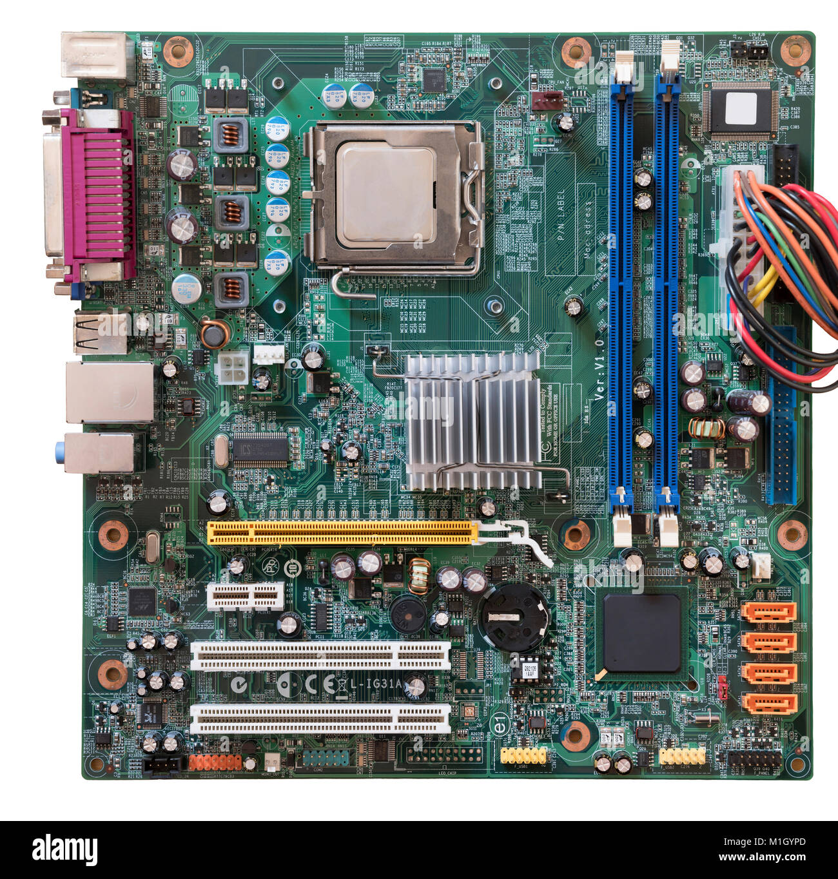

**PCI-E SLOT**

SATA CONNECTORS

1. **Demonstrate how to install a RAM module into a computer.**

**Answer:**

1. Locate the RAM slot on your motherboard.

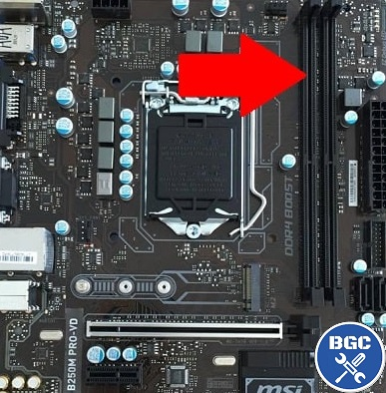

1. Push down the locking tabs at the end of each slot.

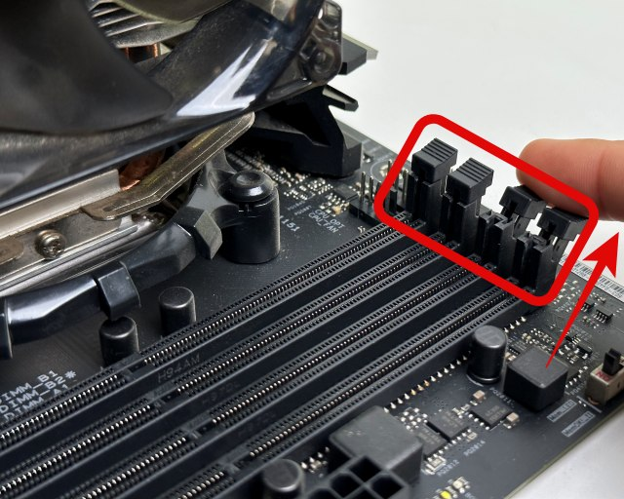

1. Line up the RAM stick with the slot, ensuring that the notch of the RAM stick matches that of the slots. Be sure that it’s centered between the latch locks.

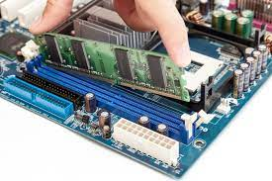

1. Push down the RAM stick straight down until it makes a clicking sound. It may take a little bit of force.

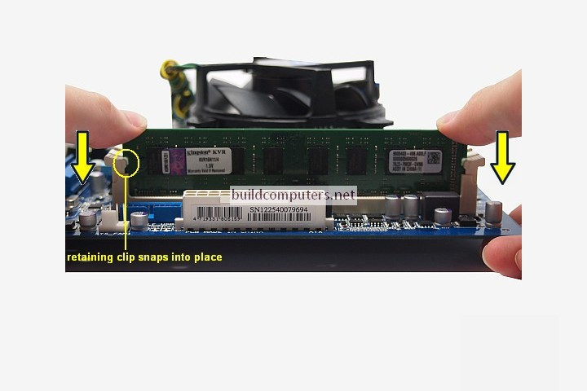

1. Once you hear the click, the RAM should be fully seated. Frequently, the latches will pop up, locking the RAM stick into place.

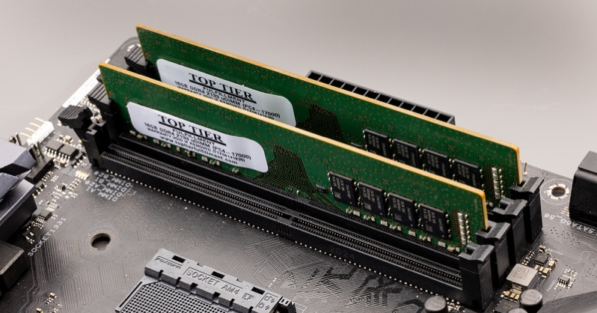

**Section 5: Essay**

1. **Discuss the importance of proper cooling mechanisms in a computer system. Include examples of cooling methods and their effectiveness.**

**Answer:**

A computer cooling system is a mechanism that removes heat from computer components, preventing them from overheating and potentially damaging the system. It typically involves dissipating heat generated by components like the CPU, GPU, and RAM into the surrounding environment, maintaining the computer's components within a safe operating temperature range. Computer components generate heat as they process information and perform calculations. Cooling systems transfer this heat away from the components and into the environment. By keeping the components cool, the cooling system ensures the computer operates reliably and efficiently. Overheating can lead to component failure, performance degradation, and system crashes. Optimal temperature operation ensures the computer runs at peak performance and provides a smooth user experience. By preventing overheating, the cooling system helps to prolong the lifespan of computer components. There are two types of cooling system are used in computer: **(1.) An Air cooling system and (2.) A Liquid cooling system.**

1. **An Air Cooling System:** uses a combination of fans and heatsinks to dissipate heat generated by components like the CPU and GPU, transferring that heat to the surrounding air. It's a simple and cost-effective method for managing temperature, but it can be noisier and potentially less efficient than liquid cooling, especially in high-performance systems. Heat from the CPU and other components is transferred to a heatsink, usually made of copper or aluminum, through thermal paste. The heatsink has a large surface area and fins to increase the area exposed to the air, maximizing heat dissipation. Fans are attached to the heatsink to draw in cool air, increase the airflow over the fins, and push the heated air away. Air is drawn into the computer case, flows over the components, picks up heat, and is expelled, creating a cooling cycle.

**Benefit:**

Air coolers are typically easier to install than liquid cooling systems, requiring less components and less complex assembly. Air cooling is generally less expensive than liquid cooling, making it a budget-friendly option. Air coolers have fewer moving parts than liquid cooling systems, potentially leading to longer lifespan and less maintenance.

**Drawbacks:** Fans can generate noticeable noise, especially at higher speeds. Air cooling may struggle to keep up with the heat generation of high-performance CPUs and GPUs, potentially leading to thermal throttling. Some air coolers can be large and may obstruct access to RAM slots or other components.

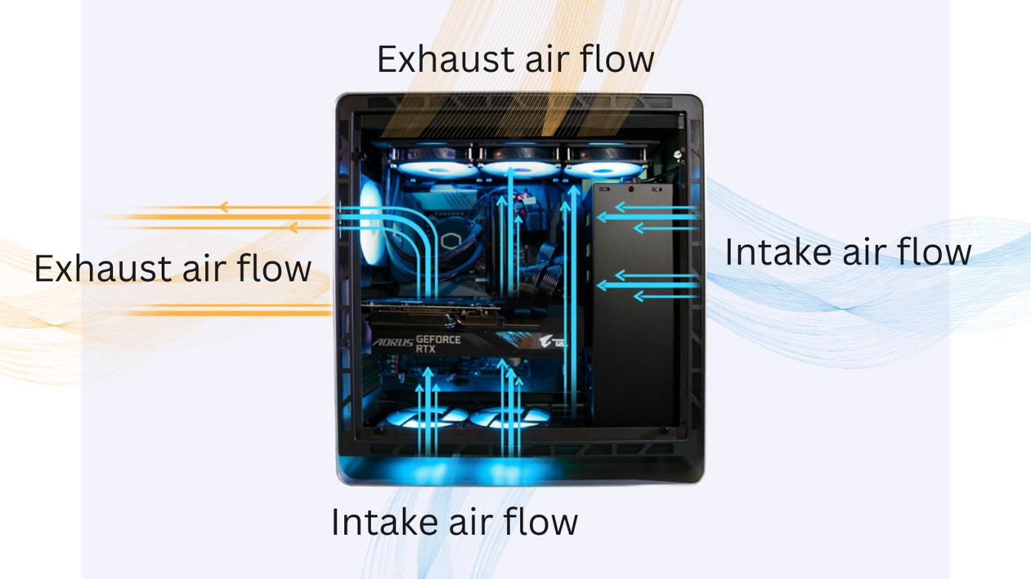

1. **A Liquid Cooling System:** uses a coolant, typically water, to transfer heat away from components like the CPU and GPU, improving cooling efficiency. This system circulates the coolant through water blocks attached to a radiator where fans dissipate the heat, before the coolant returns to the components. A pump circulates a coolant, usually water or a water-based solution, through a closed loop. Water blocks, which are attached to the CPU and GPU, absorb heat from these components. The heated coolant then travels through tubes to a radiator, where fans dissipate the heat into the surrounding air. The cooled coolant is then returned to the pump, and the cycle repeats.

**Benefit:** Liquid cooling has a quieter operation, the fans in a liquid cooled system tend to rotate more slowly and quietly than those in an air-cooling system.PC users who plan to game at maximum settings should consider water cooling. Pushing your PC to its limit requires more power and therefore will potentially heat up your system to a dangerous level. Water cooling can bring these temperatures down faster and more efficiently than air cooling. Liquid cooling systems can be very visually impressive, as you can include RGB elements to enhance your machine’s visual appeal. Custom loop cooling can look very impressive as you can mix and match parts and have a completely unique system.

**Drawback:** Custom liquid cooling will cost you a lot more than a standard air-cooling system. You are paying for the more complicated operation and the better performance. However, AIO cooling will have a price closer to air cooling.Custom liquid cooling can be laborious to set up, especially for beginner PC builders. An AIO (all-in-one) liquid cooler is easier to install and should take you around 30 minutes. However, either way it can also be quite unnerving to have water running through your system. Custom liquid cooling systems require more maintenance than air cooling, as you need to sustain proper fluid levels, and make sure the components are clean and functional. Also, if any of the parts of a custom cooling system fail it could be catastrophic for your computer. AIO requires less maintenance and as everything comes assembled, the risk of the system leaking is reduced.

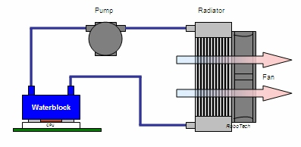

14. **Explain the concept of bus width and its significance in computer**

**architecture.**

**Answer:**

In computer architecture, bus width refers to the number of parallel data lines within a bus, determining how much data can be transferred simultaneously. A wider bus means more bits can be transferred in a single cycle, increasing data transfer speed and bandwidth, ultimately impacting the overall performance of a computer system. A bus is a collection of electrical pathways (or wires) that act as a communication channel between different components within a computer system, such as the CPU, memory, and peripherals. Buses are categorized into data, address, and control buses, each serving a specific purpose in data transfer. The width of a bus is the number of parallel data lines it contains. Each data line can carry a single bit of information. A wider bus can transmit more bits simultaneously, increasing the rate at which data can be transferred. There is total Three types of bus in computer system: 1.) Address Bus, 2.) Data Bus, 3.) Control Bus.

1. **Address Bus:** A collection of wires used to identify particular location in main memory is called Address Bus. Or in other words, the information used to describe the memory locations travels along the address bus. The address bus transports memory addresses which the processor wants to access to read or write data. The address bus is unidirectional. The size of address bus determines how many unique memory locations can be addressed.
2. **Data Bus:** A collection of wires through which data is transmitted from one part of a computer to another is called Data Bus. Data Bus can be thought of as a highway on which data travels within a computer. The main objective of data bus is transfer of the data between microprocessor input/out devices or memory. The data bus transfers instructions coming from or going to the processor. The data bus is bidirectional because the data can flow in either direction from CPU to memory (or input/output device) or from memory to the CPU. The size (width) of bus determines how much data can be transmitted at one time.
3. **Control Bus:** The connections that carry control information between the CPU and other devices within the computer is called Control Bus. The main objective of control bus is all signals controller carried from processor to other hardware device. The control bus transports orders and synchronisation signal coming from the control unit and travelling to all other hardware components The Control bus is bidirectional because the data can flow in either direction from CPU to memory (or input/output device) or from memory to the CPU. It also transmits response signals from the hardware.

**Significance of Bus Width:**

1. **Data Transfer Rate:** A wider bus translates to a higher data transfer rate because more bits can be sent simultaneously.
2. **System Performance:** Increased data transfer rate directly impacts system performance, enabling faster data access and processing, ultimately leading to quicker execution of programs and improved overall responsiveness.
3. **Memory Addressing:** The width of the address bus determines the amount of memory a system can access. A wider address bus allows for a larger address space, enabling the CPU to access more memory locations and potentially improve overall system performance by reducing reliance on slower virtual memory.
4. **Cost and Complexity:** While wider buses offer performance benefits, they also come with increased manufacturing costs and design complexity due to the larger number of physical connections required.

**Examples:**

* An 8-bit data bus can transfer 8 bits of data at a time, while a 32-bit data bus can transfer 32 bits simultaneously.
* The address bus width determines the maximum amount of memory a system can address. For example, a 32-bit address bus can address up to 4GB of RAM.
* Modern systems often use 64-bit buses for both data and address, enabling high-performance data transfer and memory access.

